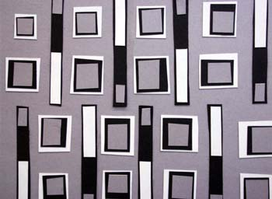
Project #1 – Principles of Design Collage

You must create 3 different collages that illustrate a different Principle of Design. If your design winds up illustrating more than one (which is likely to happen) that is OK.

REQUIREMENTS:

- PUSH YOURSELF. The first thing that pops into your head is likely the first thing that pops into everyone head. LEARN to be CREATIVE. It does take time, but YOU CAN DO IT! Easy isn’t always interesting.
- Your design must go off of all 4 edges of the paper
- Your design must have overlapping forms.
- Black/White/Gray are the dominant colors to be used
- On the back you need to write what the main principle you chose to illustrate was. Also write any other ones you think you used.

You will begin to understand that you have been using the Principles of Design with out even knowing it. The goal is to become aware of it so that you use them with purpose and your artwork will become more thoughtful/interesting.

RUBRIC:

- Effectively shows the intended design principle
- Creative/unique/thoughtful way to solve the problem
- Has overlapping forms and has objects that go off of all edges of the paper.
- Good Craftsmanship (Not sloppy or rushed)
Some Examples:
Look but DON’T COPY!!

You will make FAR more interesting work and have FAR more fun with the assignment if you look… and then look away. Forget what you saw and just let your mind be creative.
